|  |
| --- |
|  |
| The Documentation |
| [Type the document subtitle] |
|  |
| **[Your Name]** |
| **[Pick the date]** |

[Type the abstract of the document here. The abstract is typically a short summary of the contents of the document. Type the abstract of the document here. The abstract is typically a short summary of the contents of the document.]

Table of Contents

[To update the table of contents, right click the message below and select Update Field (F9 on PC, ⌥⌘U on Mac).]

**No table of contents entries found.**

1. Pages
   1. Page Tree

Home  
 Start as Student  
 Lectures

* 1. Home
     1. User Interface

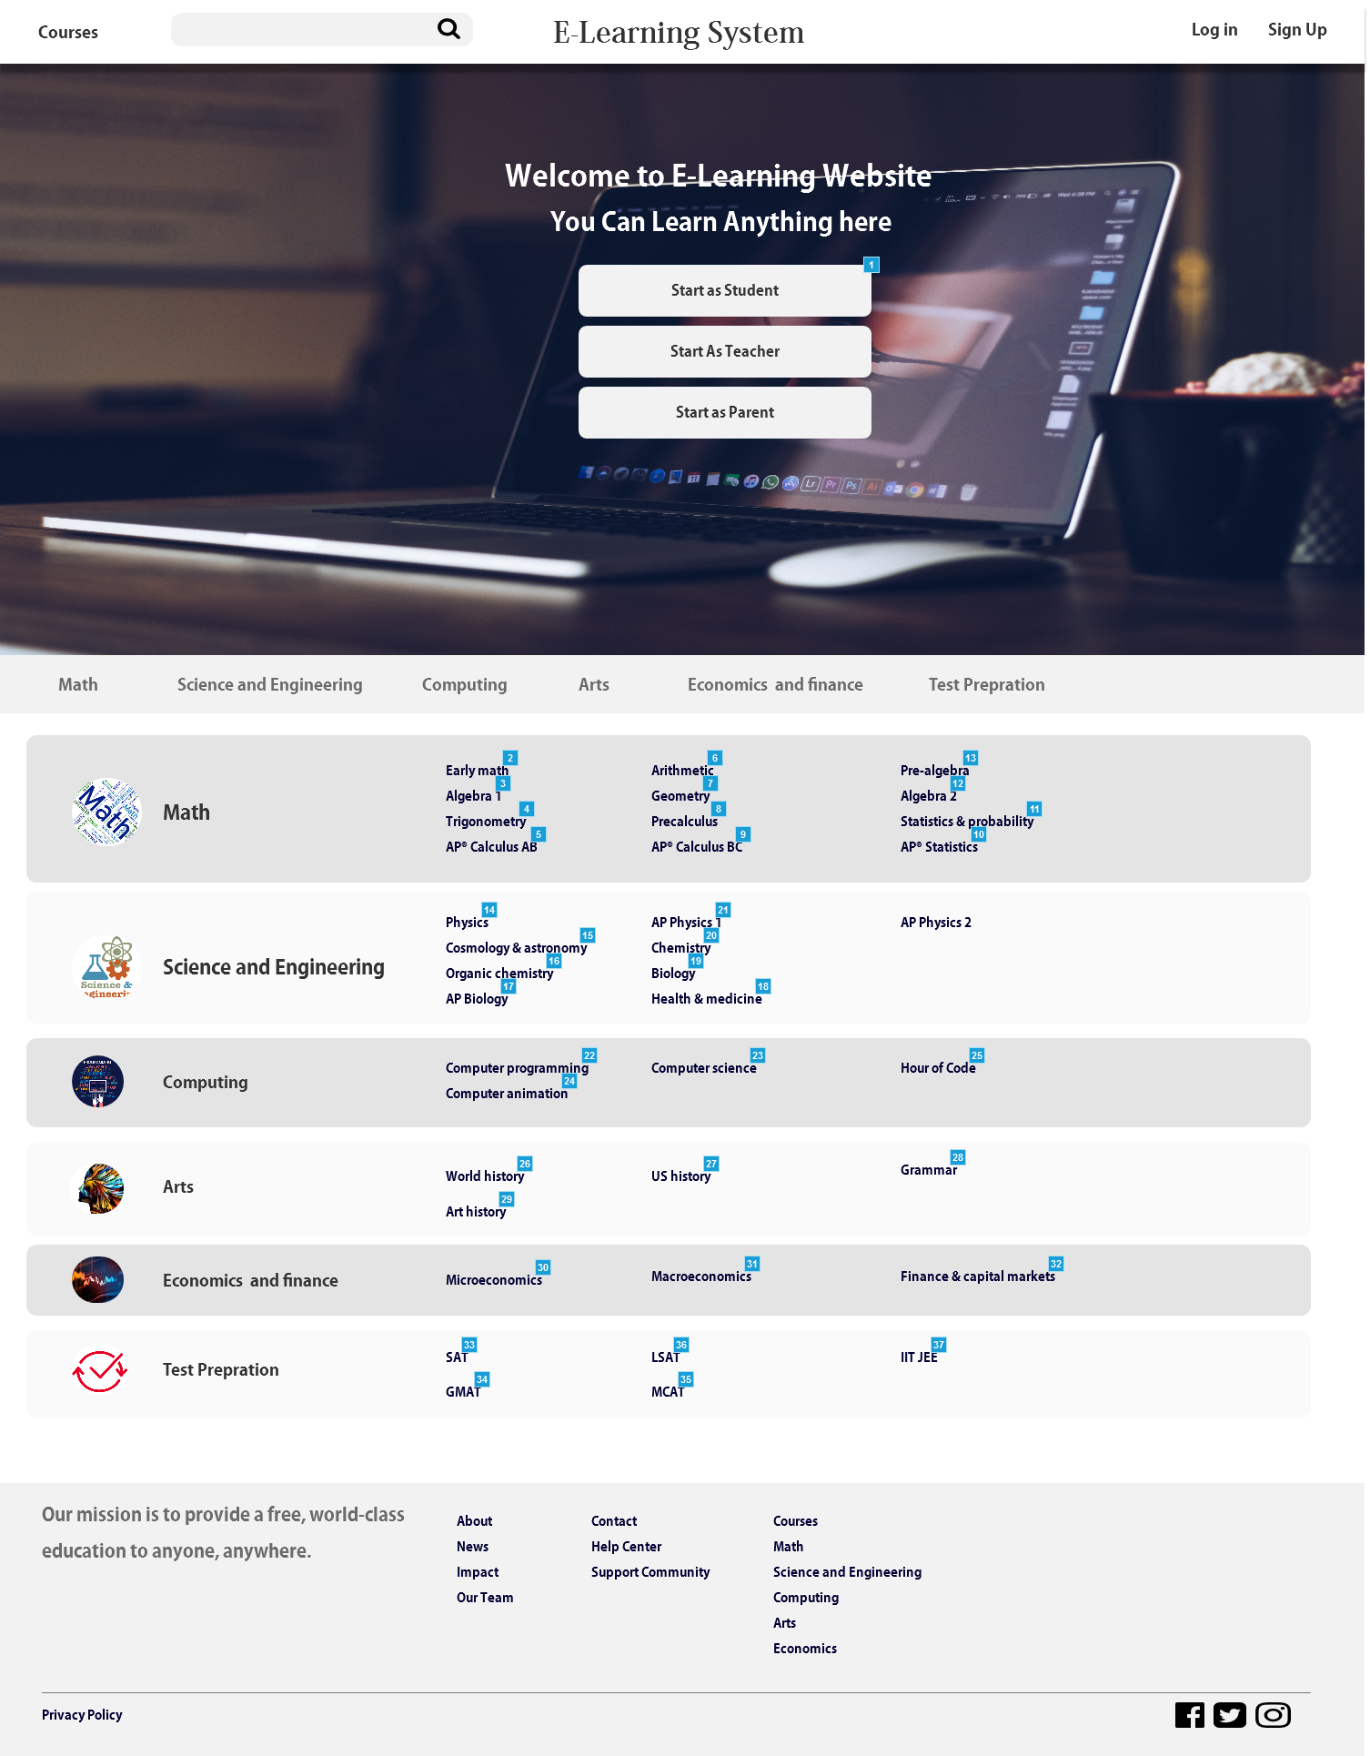

* + 1. Widget Table

| Footnote | Name | Interactions |
| --- | --- | --- |
| 1 |  | OnClick:  Case 1:  Scroll to mathh (y only) linear 500ms |
| 2 |  | OnClick:  Case 1:  Open Start as Student in Current Window |
| 3 |  | OnClick:  Case 1:  Open Start as Student in Current Window |
| 4 |  | OnClick:  Case 1:  Open Start as Student in Current Window |
| 5 |  | OnClick:  Case 1:  Open Start as Student in Current Window |
| 6 |  | OnClick:  Case 1:  Open Start as Student in Current Window |
| 7 |  | OnClick:  Case 1:  Open Start as Student in Current Window |
| 8 |  | OnClick:  Case 1:  Open Start as Student in Current Window |
| 9 |  | OnClick:  Case 1:  Open Start as Student in Current Window |
| 10 |  | OnClick:  Case 1:  Open Start as Student in Current Window |
| 11 |  | OnClick:  Case 1:  Open Start as Student in Current Window |
| 12 |  | OnClick:  Case 1:  Open Start as Student in Current Window |
| 13 |  | OnClick:  Case 1:  Open Start as Student in Current Window |
| 14 |  | OnClick:  Case 1:  Open Start as Student in Current Window |
| 15 |  | OnClick:  Case 1:  Open Start as Student in Current Window |
| 16 |  | OnClick:  Case 1:  Open Start as Student in Current Window |
| 17 |  | OnClick:  Case 1:  Open Start as Student in Current Window |
| 18 |  | OnClick:  Case 1:  Open Start as Student in Current Window |
| 19 |  | OnClick:  Case 1:  Open Start as Student in Current Window |
| 20 |  | OnClick:  Case 1:  Open Start as Student in Current Window |
| 21 |  | OnClick:  Case 1:  Open Start as Student in Current Window |
| 22 |  | OnClick:  Case 1:  Open Start as Student in Current Window |
| 23 |  | OnClick:  Case 1:  Open Start as Student in Current Window |
| 24 |  | OnClick:  Case 1:  Open Start as Student in Current Window |
| 25 |  | OnClick:  Case 1:  Open Start as Student in Current Window |
| 26 |  | OnClick:  Case 1:  Open Start as Student in Current Window |
| 27 |  | OnClick:  Case 1:  Open Start as Student in Current Window |
| 28 |  | OnClick:  Case 1:  Open Start as Student in Current Window |
| 29 |  | OnClick:  Case 1:  Open Start as Student in Current Window |
| 30 |  | OnClick:  Case 1:  Open Start as Student in Current Window |
| 31 |  | OnClick:  Case 1:  Open Start as Student in Current Window |
| 32 |  | OnClick:  Case 1:  Open Start as Student in Current Window |
| 33 |  | OnClick:  Case 1:  Open Start as Student in Current Window |
| 34 |  | OnClick:  Case 1:  Open Start as Student in Current Window |
| 35 |  | OnClick:  Case 1:  Open Start as Student in Current Window |
| 36 |  | OnClick:  Case 1:  Open Start as Student in Current Window |
| 37 |  | OnClick:  Case 1:  Open Start as Student in Current Window |

* + 1. Unnamed
       1. State1
       2. User Interface



* + - 1. Widget Table

| Footnote | Interactions |
| --- | --- |
| 1 | OnClick:  Case 1:  Scroll to mathh (y only) linear 500ms |
| 2 | OnClick:  Case 1:  Scroll to sc (y only) linear 500ms |
| 3 | OnClick:  Case 1:  Scroll to css (y only) linear 500ms |
| 4 | OnClick:  Case 1:  Scroll to ar (y only) linear 500ms |
| 5 | OnClick:  Case 1:  Scroll to ecf (y only) linear 500ms |
| 6 | OnClick:  Case 1:  Scroll to test (y only) linear 500ms |

* 1. Start as Student
     1. User Interface

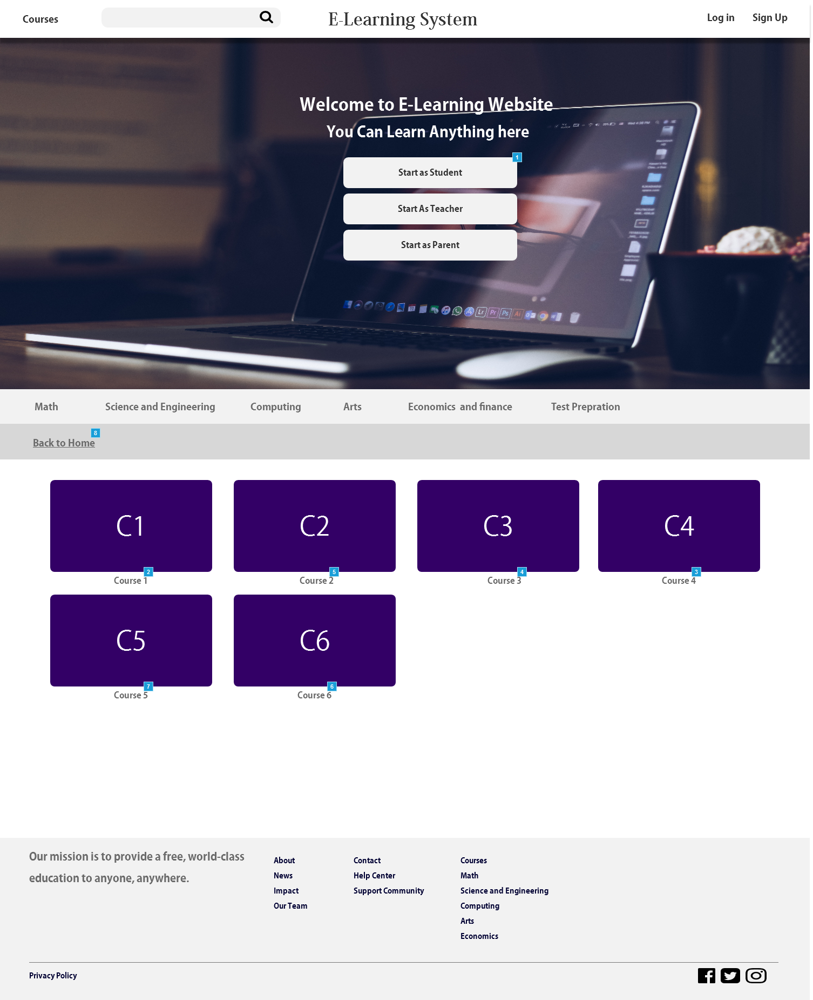

* + 1. Widget Table

| Footnote | Name | Interactions |
| --- | --- | --- |
| 1 |  | OnClick:  Case 1:  Scroll to Widget |
| 2 |  | OnClick:  Case 1:  Open Lectures in Current Window |
| 3 |  | OnClick:  Case 1:  Open Lectures in Current Window |
| 4 |  | OnClick:  Case 1:  Open Lectures in Current Window |
| 5 |  | OnClick:  Case 1:  Open Lectures in Current Window |
| 6 |  | OnClick:  Case 1:  Open Lectures in Current Window |
| 7 |  | OnClick:  Case 1:  Open Lectures in Current Window |
| 8 |  | OnClick:  Case 1:  Open Home in Current Window OnLoad:  Case 1:  Scroll to (Rectangle) (y only) linear 500ms |

* + 1. Unnamed
       1. State1
       2. User Interface



* + - 1. Widget Table

| Footnote | Interactions |
| --- | --- |
| 1 | OnClick:  Case 1:  Scroll to Widget |
| 2 | OnClick:  Case 1:  Scroll to Widget |
| 3 | OnClick:  Case 1:  Scroll to Widget |
| 4 | OnClick:  Case 1:  Scroll to Widget |
| 5 | OnClick:  Case 1:  Scroll to Widget |
| 6 | OnClick:  Case 1:  Scroll to Widget |

* 1. Lectures
     1. User Interface

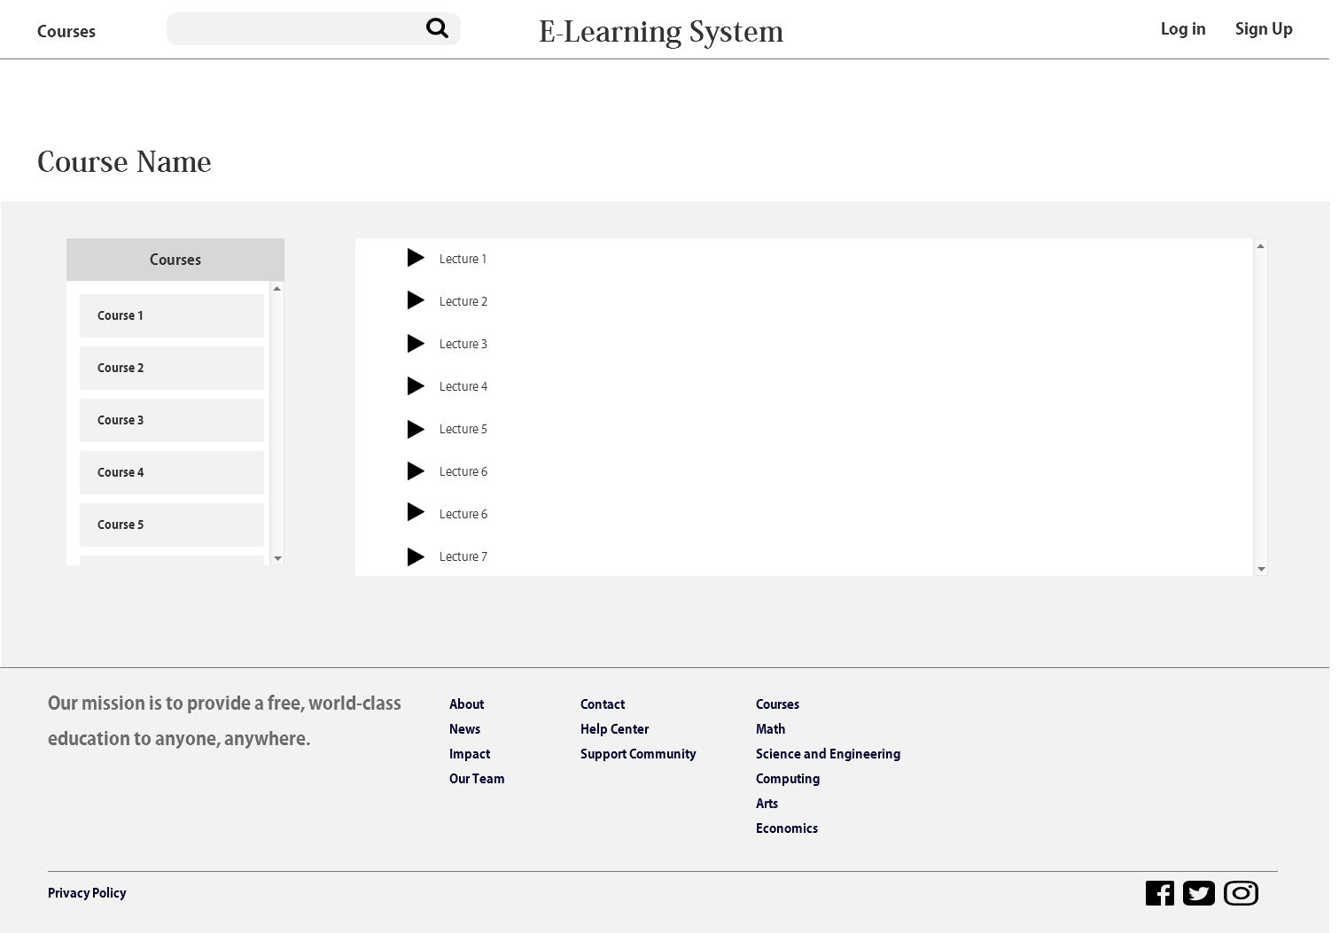

* + 1. Unnamed
       1. State1
       2. User Interface

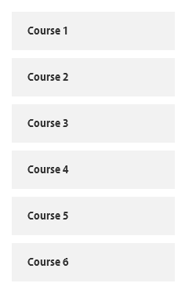

* + 1. Unnamed
       1. State1
       2. User Interface

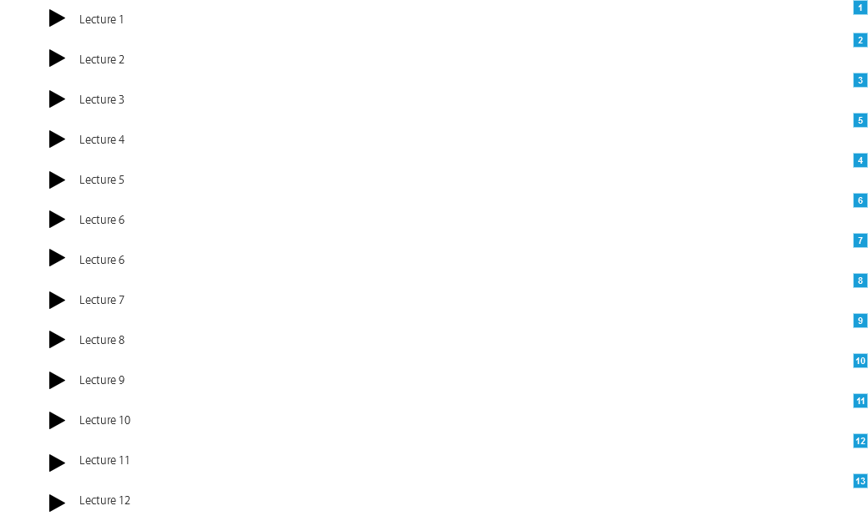

* + - 1. Widget Table

| Footnote | Interactions |
| --- | --- |
| 1 | OnClick:  Case 1:  Show Video Player slide up 500 ms treat as lightbox |
| 2 | OnClick:  Case 1:  Show Video Player slide up 500 ms treat as lightbox |
| 3 | OnClick:  Case 1:  Show Video Player slide up 500 ms treat as lightbox |
| 4 | OnClick:  Case 1:  Show Video Player slide up 500 ms treat as lightbox |
| 5 | OnClick:  Case 1:  Show Video Player slide up 500 ms treat as lightbox |
| 6 | OnClick:  Case 1:  Show Video Player slide up 500 ms treat as lightbox |
| 7 | OnClick:  Case 1:  Show Video Player slide up 500 ms treat as lightbox |
| 8 | OnClick:  Case 1:  Show Video Player slide up 500 ms treat as lightbox |
| 9 | OnClick:  Case 1:  Show Video Player slide up 500 ms treat as lightbox |
| 10 | OnClick:  Case 1:  Show Video Player slide up 500 ms treat as lightbox |
| 11 | OnClick:  Case 1:  Show Video Player slide up 500 ms treat as lightbox |
| 12 | OnClick:  Case 1:  Show Video Player slide up 500 ms treat as lightbox |
| 13 | OnClick:  Case 1:  Show Video Player slide up 500 ms treat as lightbox |

* + 1. Video Player
       1. State1
       2. User Interface

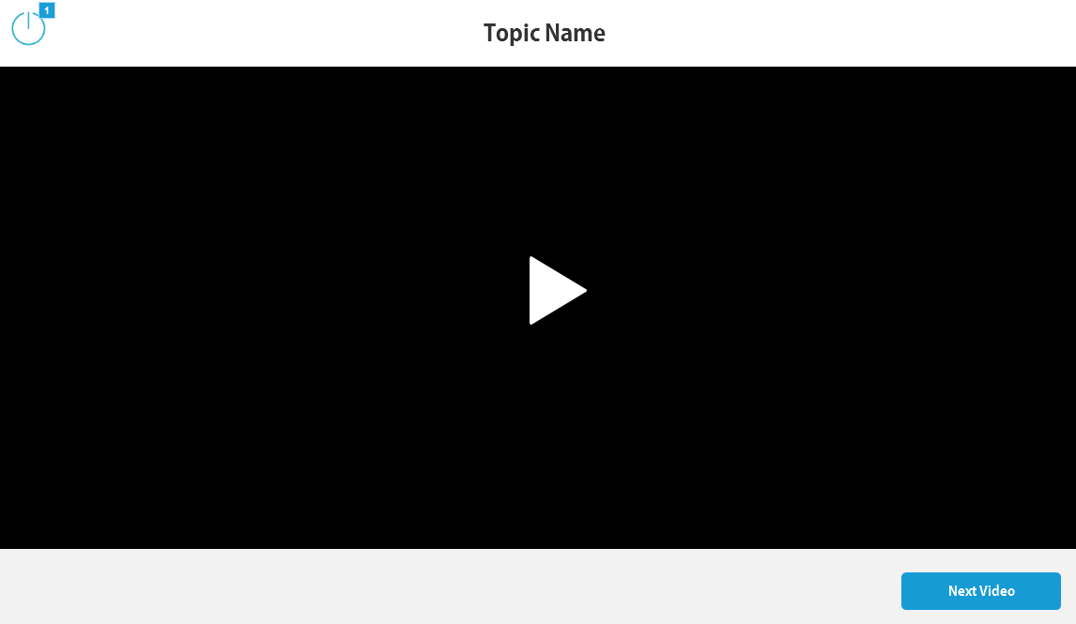

* + - 1. Widget Table

| Footnote | Interactions |
| --- | --- |
| 1 | OnClick:  Case 1:  Hide Video Player |